Student’s name | …………………………………………………….…… | Grade | 1
Subject | Computer | Week No. | 6
Lesson Title | Parts of Computers | Unit
Worksheet No. ( 6 )
Instruction: write their names next to it.

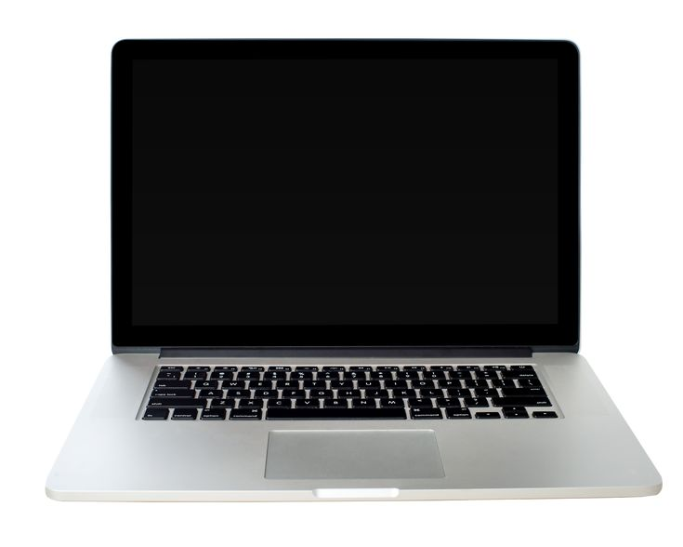

Good Luck

